Project overview

**Objective:**

Collision Analytics Project Overview Objective This project processes collision data to derive meaningful insights, such as collision trends, impact by geography, and involvement type. The data flows from ingestion to visualization, leveraging Google Cloud Platform (GCP) tools like Composer, BigQuery, Dataproc, and Looker.

**Architecture**

**1. Data Ingestion**

Source CSV files containing raw collision data with 23 columns.

Landing Location Google Cloud Storage (GCS).

Process Composer DAG orchestrates the ingestion process using the GCS Operator to move files from a source bucket to a landing bucket in GCS.

**2. Data Transformation**

Transformations - Split the source data into a normalized schema consisting of four BigQuery

tables: events, collision_outcomes, location, and collision_details clean and validate the data. The same Composer DAG triggers a Dataproc cluster to process the files and load the transformed data into BigQuery. -

Steps

1. Create Dataproc Cluster: task in the DAG creates a temporary Dataproc cluster.

2. Submit Dataproc Job PySpark job is submitted to process the data and load it into BigQuery.

3. Delete Dataproc Cluster After the job completes, the cluster is deleted to optimize costs.

Data Consumption,Visualization and Dashboarding.Data is visualized using Looker connecting directly to the BigQuery dataset.Dashboards provide insights such as Collisions by year, month, and division.Top neighborhoods with the highest collisions. Collisions by time range and involvement type.

**Detailed Workflow**

Steps

1: Data Ingestion:Composer DAG Overview Task ingest_to_gcs Uses the GoogleCloudStorageToGoogleCloudStorageOperator. Moves raw collision data from the source bucket (source-data-bucket) to the landing bucket (landing-data-bucket). Landing Bucket Structure Folder organization: gs://landing-data-bucket/raw/YYYY/MM/DD/

**Code Snippet:**

python from airflow.providers.google.cloud.transfers.gcs_to_gcs import GCSToGCSOperator ingest_to_gcs = GCSToGCSOperator( task_id="ingest_to_gcs", source_bucket="source-data-bucket", source_object="collision_data.csv", destination_bucket="landing-data-bucket", destination_object="raw/{{ ds }}/collision_data.csv", move_object=True, )

Step 2: Data Transformation:Composer DAG Overview

Task 1: create_cluster - Creates a Dataproc cluster using the DataprocCreateClusterOperator. Task 2: submit_spark_job Submits a PySpark job to process and transform the data.

Task 3: delete_cluster Deletes the Dataproc cluster using the DataprocDeleteClusterOperator.

**Key Components:**

1. Dataproc Cluster Configuration Temporary cluster with optimized resources for the job.

2. PySpark Job Reads the source CSV from GCS. Processes data into four normalized BigQuery tables.Writes the data to BigQuery using google-cloud-bigquery API.

Code Snippet for Dataproc DAG

python from airflow.providers.google.cloud.operators.dataproc import DataprocCreateClusterOperator,

DataprocSubmitJobOperator,

DataprocDeleteClusterOperator

create_cluster = DataprocCreateClusterOperator(

task_id="create_cluster_task",

project_id=PROJECT_ID,

cluster_config=CLUSTER_CONFIG,

region=REGION,

cluster_name=CLUSTER_NAME,

)

submit_spark_job = DataprocSubmitJobOperator(

task_id="pyspark_task",

job=PYSPARK_JOB,

region=REGION,

project_id=PROJECT_ID

)

delete_cluster = DataprocDeleteClusterOperator(

task_id="delete_cluster_task",

project_id=PROJECT_ID,

cluster_name=CLUSTER_NAME,

region=REGION,

)

**LOOKER STUDIO REPORTING**

Dashboarding in Looker Connects to BigQuery we can analyze the data and build visualizations. Some sample data visualization by using BIgQuery tables has been shown in the document below.

We can analyze data with wide range of futures like below

* Dashboard Features Collisions by Year
* Year-wise collision counts.
* Top Division and Neighborhood Insights into divisions and neighborhoods with the highest collisions.
* Collisions by Time Range Time-of-day analysis for involvement types.

**Key Metrics and Insights**

* Collisions by Year Track trends to identify years with high collision rates.
* Collisions by Division Understand which police divisions have the most collisions.
* Involvement Type Analyze whether automobiles, pedestrians, or cyclists are involved more frequently.
* High-Risk Neighborhoods Identify neighborhoods with the highest collision rates for targeted interventions.

**Automation**

The pipeline is fully automated using Composer, Dataproc, and BigQuery. The use of GCP tools ensures scalability for future data growth. Temporary Dataproc clusters reduce costs by running only during processing tasks.

**BigQuery Tables**

—-------------------

Events

Locations

Collision_details

Collision_outcomes

**Events Schema**

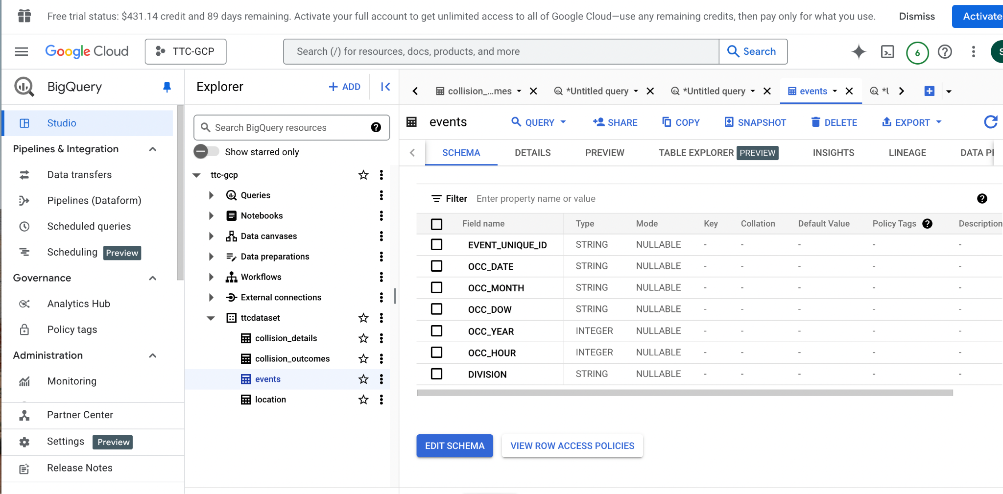

**Sample Query**

SELECT EVENT_UNIQUE_ID,

OCC_DATE,

OCC_MONTH,

OCC_DOW,

OCC_YEAR,

CAST(OCC_HOUR AS STRING),

DIVISION FROM `ttc-gcp.ttcdataset.events` WHERE OCC_YEAR=2024

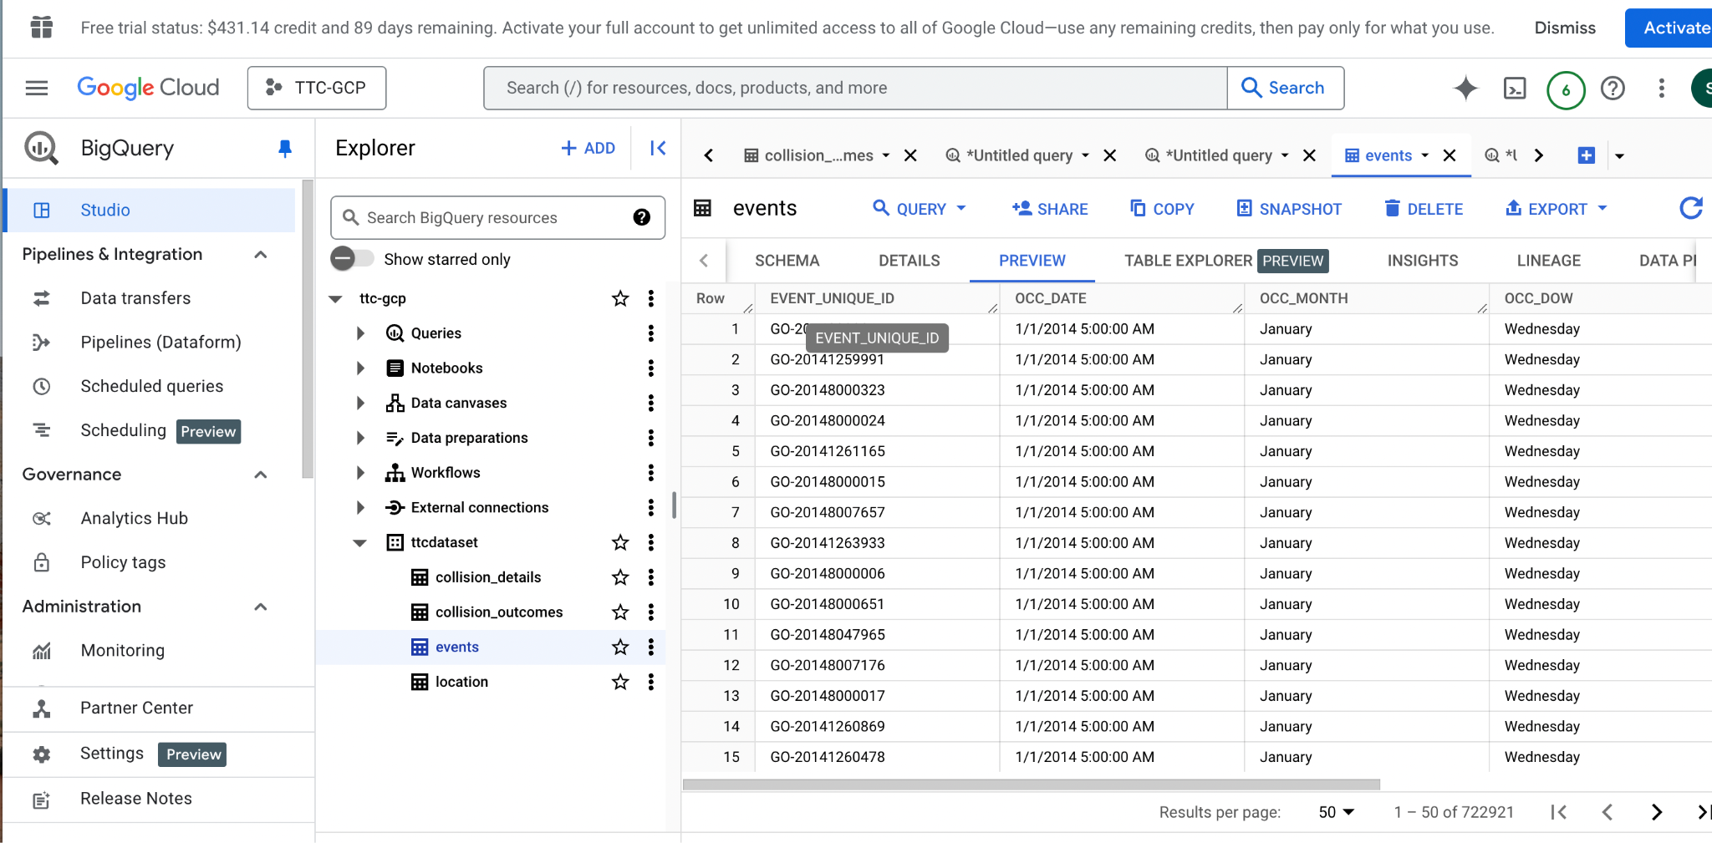

**Looker Studio Report**

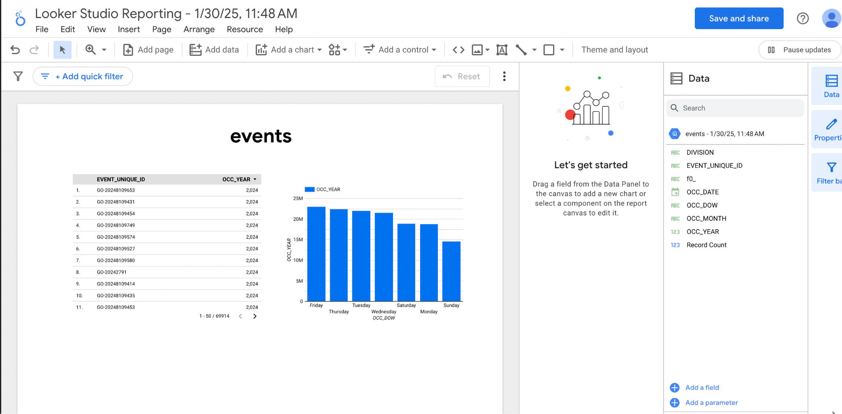

2) **Locations Schema**

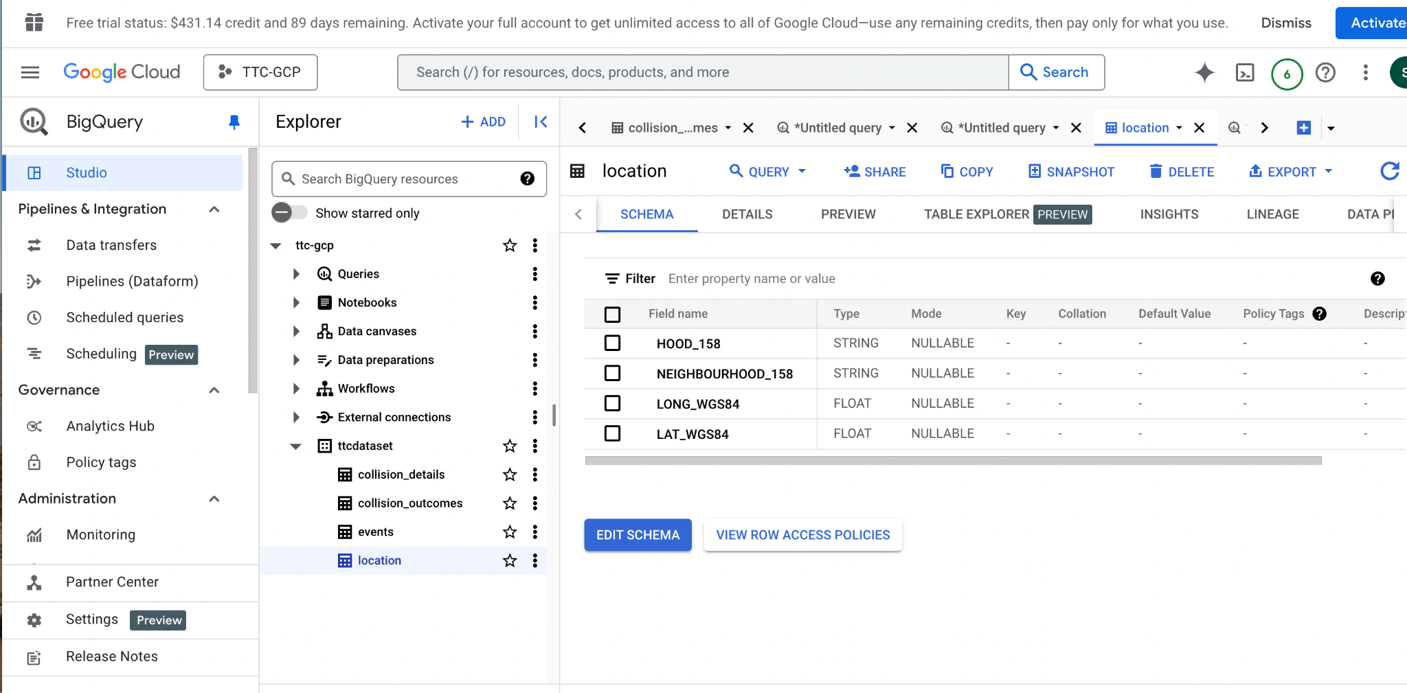

**Sample Query**

SELECT FROM `ttc-gcp.ttcdataset.location` LIMIT 1000

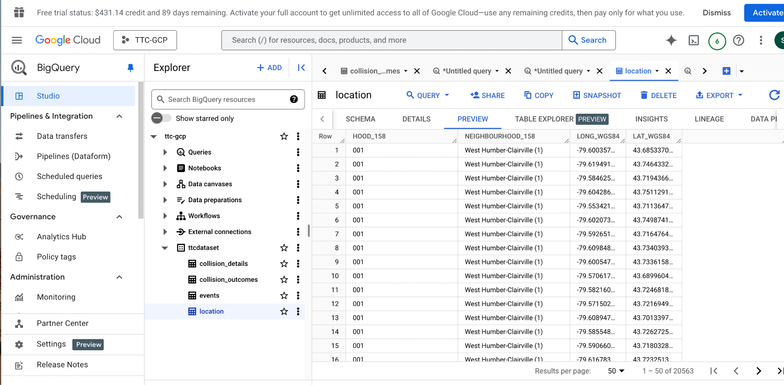

**Looker Studio Report**

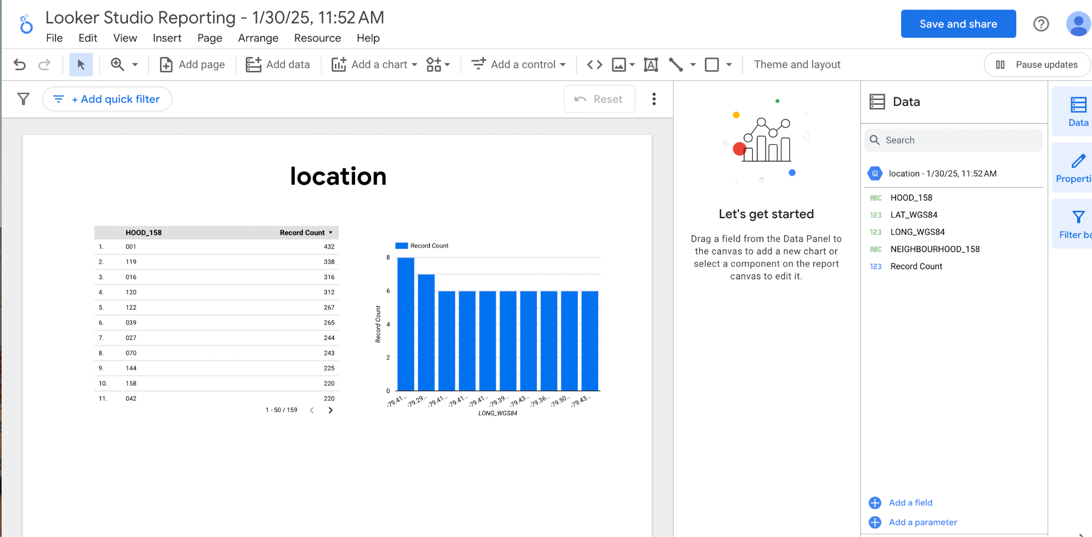

3) **collision_details Schema**

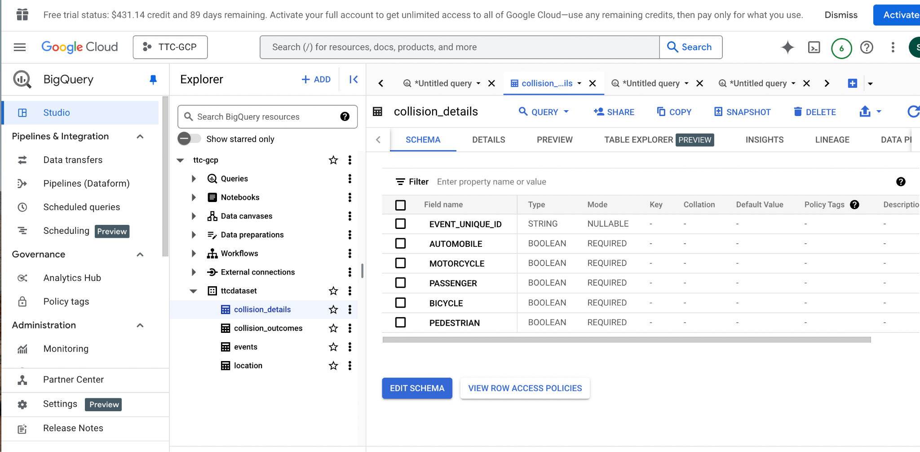

**Sample Query**

Select *from ttc-gcp.ttcdataset.collision_details ;

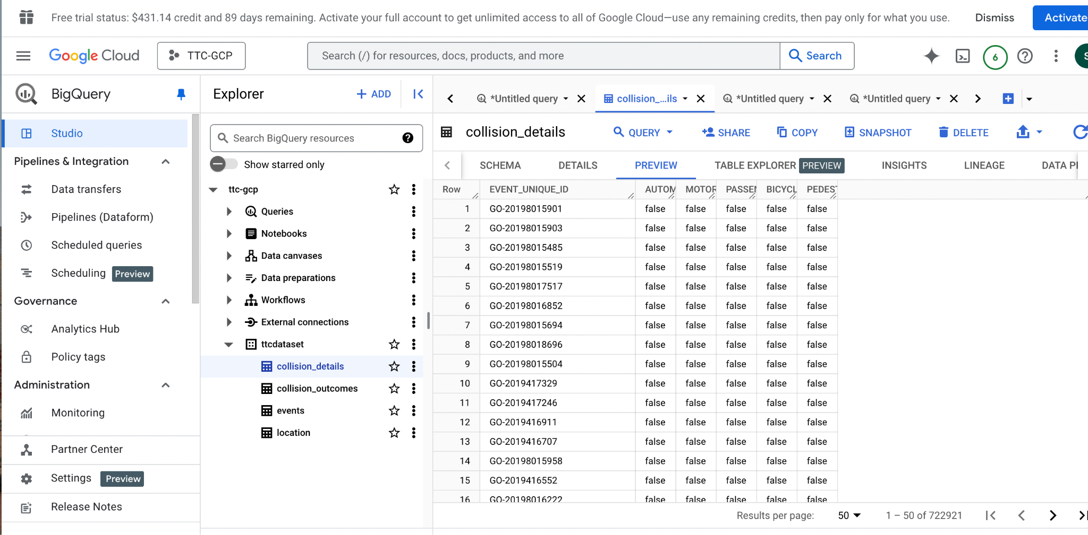

**Looker Studio Report**

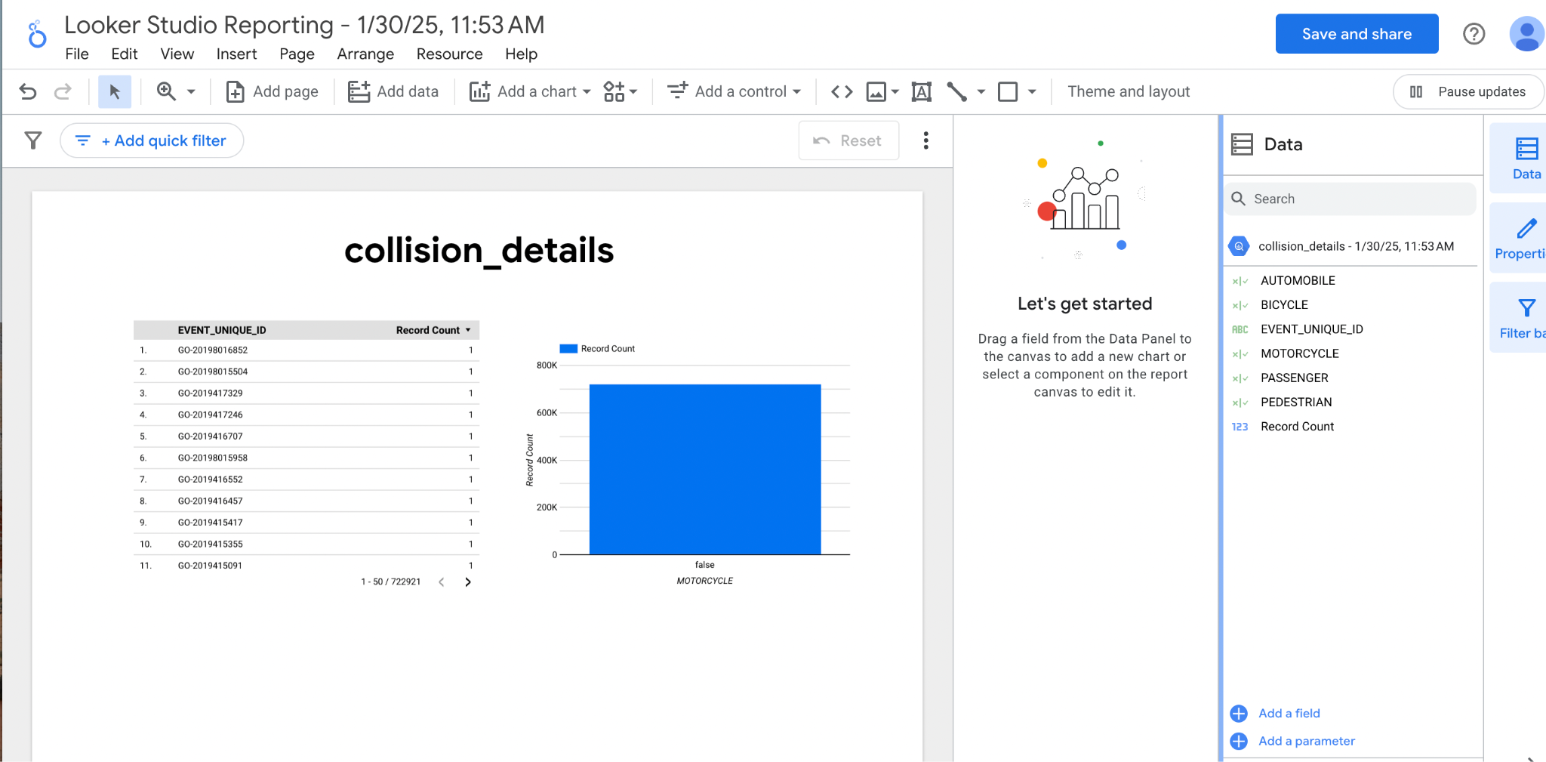

4) **collision_outcomes Schema**

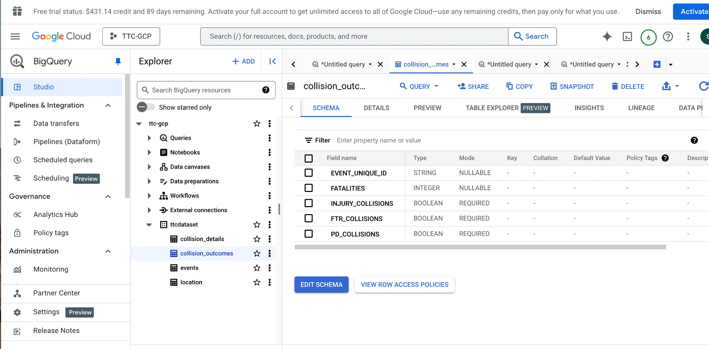

**Sample Query**

Select *from ttc-gcp.ttcdataset.collision_details;

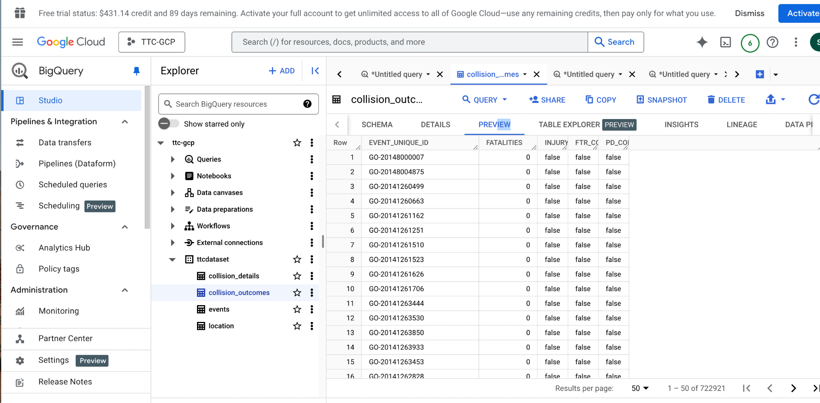

**Looker Studio Report**

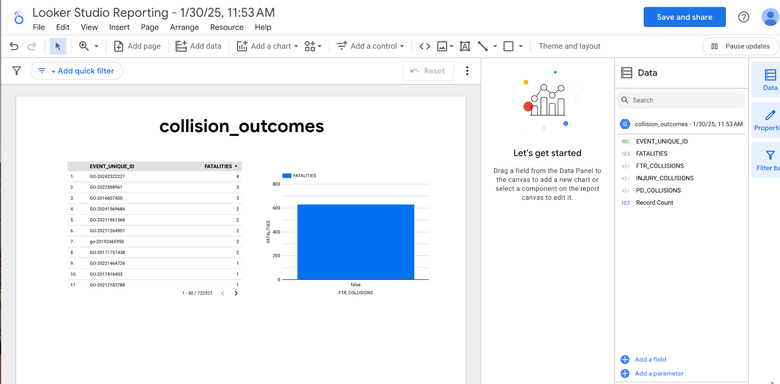

**Sample queries outputs using looker**

SELECT

DIVISION AS Police_Division,

COUNT(EVENT_UNIQUE_ID) AS Total_Collisions

FROM

`ttc-gcp.ttcdataset.events`

GROUP BY

DIVISION

ORDER BY

Total_Collisions DESC;

This query calculates the total number of collisions grouped by police division.

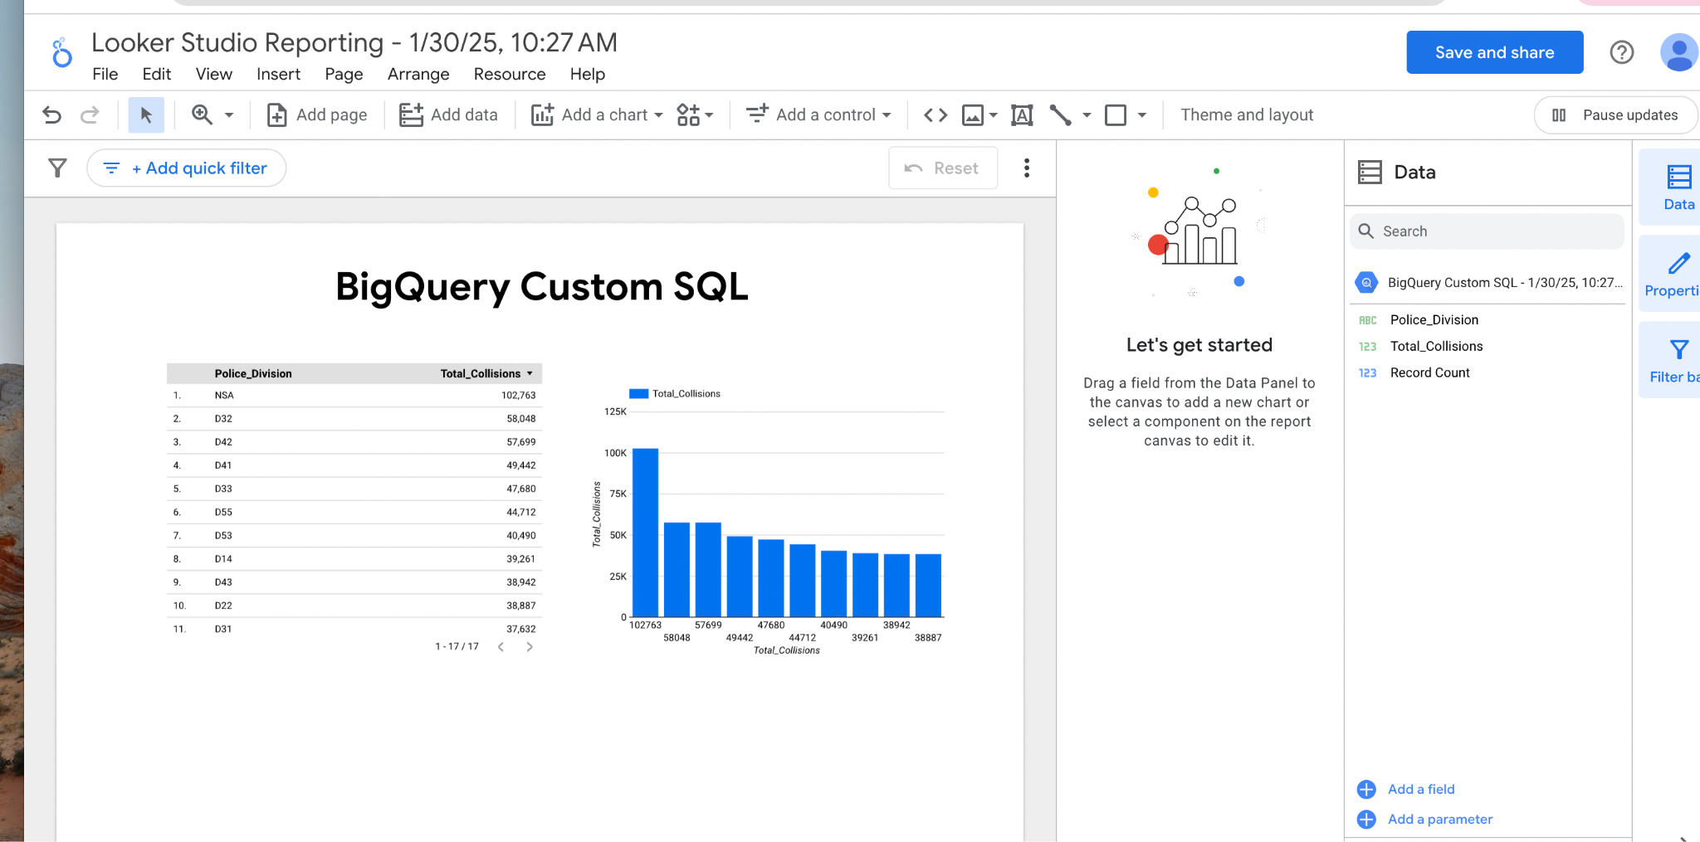

2) SELECT

OCC_MONTH AS Month,

COUNT(EVENT_UNIQUE_ID) AS Total_Collisions

FROM

`your_project.your_dataset.events`

GROUP BY

OCC_MONTH

ORDER BY

Total_Collisions DESC;

This query calculates the total number of collisions grouped by month.

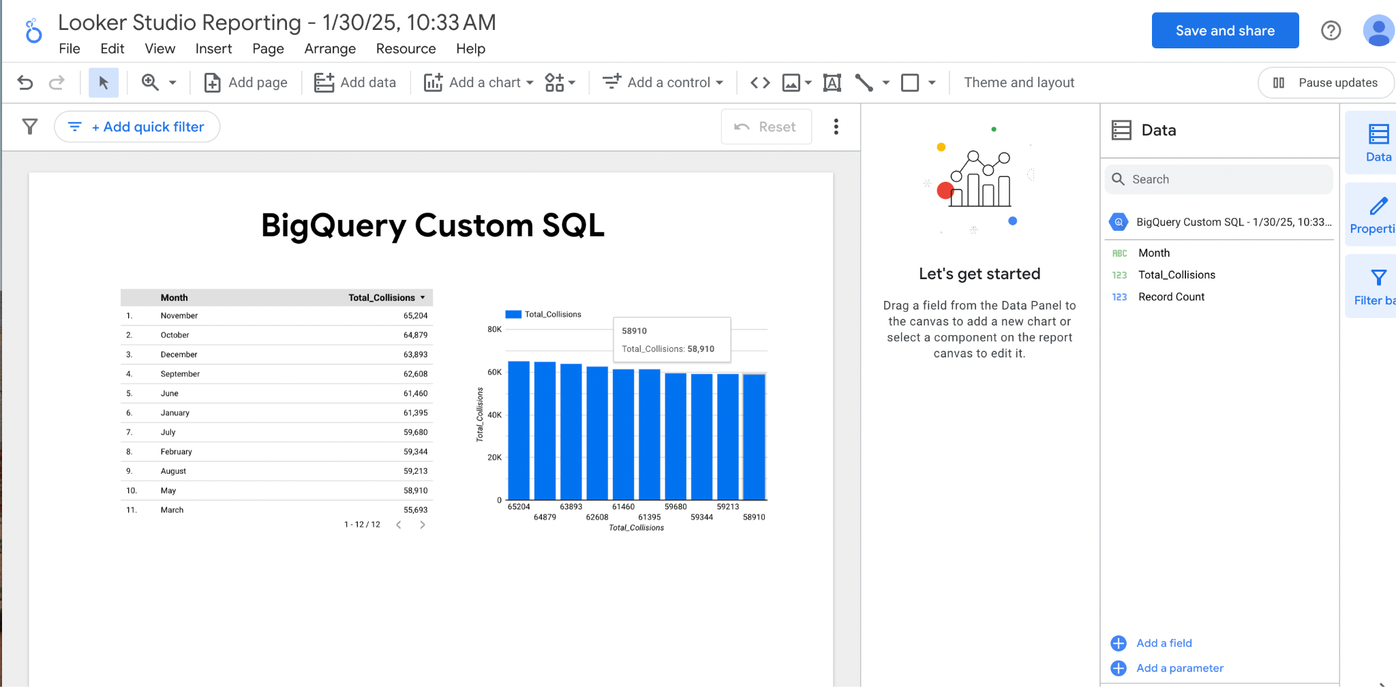

3)SELECT

DIVISION AS Police_Division,

COUNT(EVENT_UNIQUE_ID) AS Total_Collisions

FROM

`your_project.your_dataset.events`

GROUP BY

DIVISION

ORDER BY

Total_Collisions DESC ;

This query finds the division with the highest number of collisions.

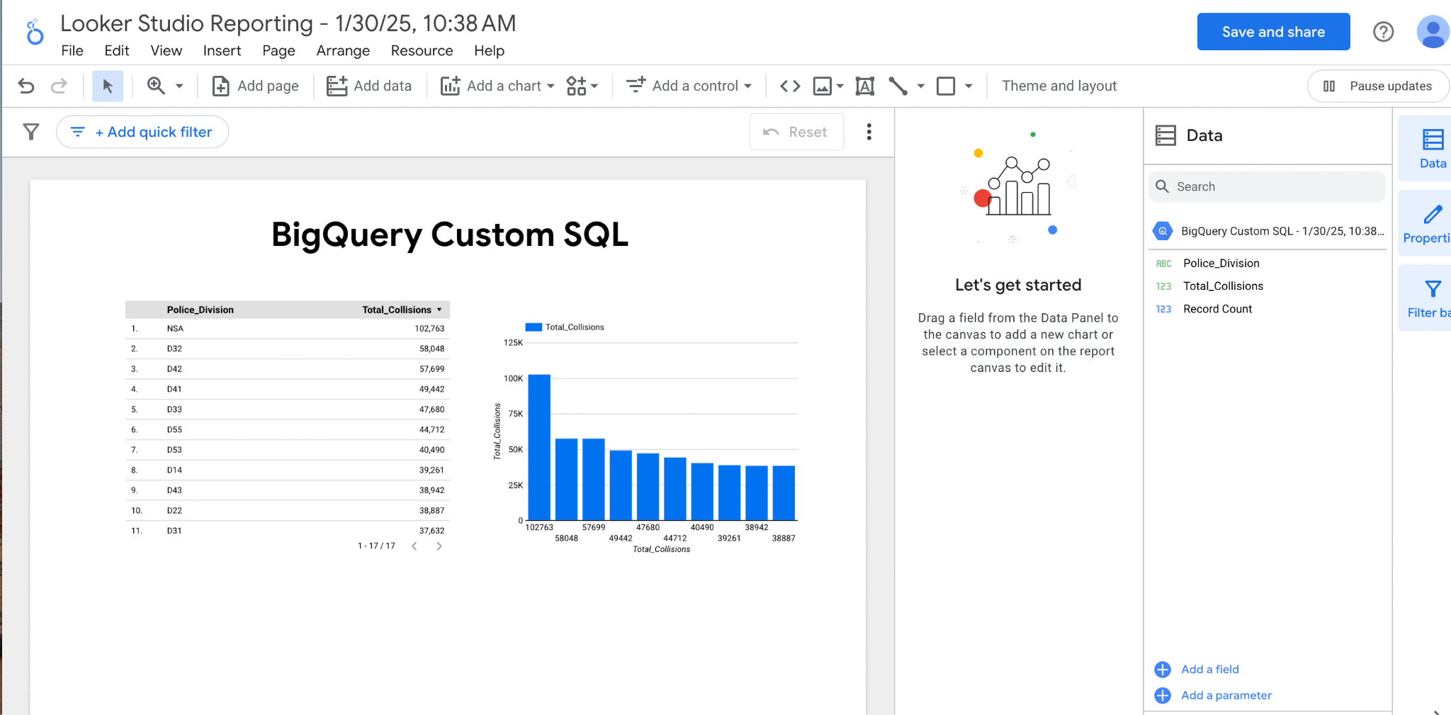

4) SELECT

DIVISION AS Police_Division,

COUNT(EVENT_UNIQUE_ID) AS Total_Collisions

FROM

`your_project.your_dataset.events`

GROUP BY

DIVISION

ORDER BY

Total_Collisions DESC ;

This query finds the division with the highest number of collisions.

